**Assignment : 3**

1. write a SQL query to find Employees who have the biggest salary in their Department.

select emp_name,dept_id from Employee where salary

in(select max(salary) from Employee group by dept_id)

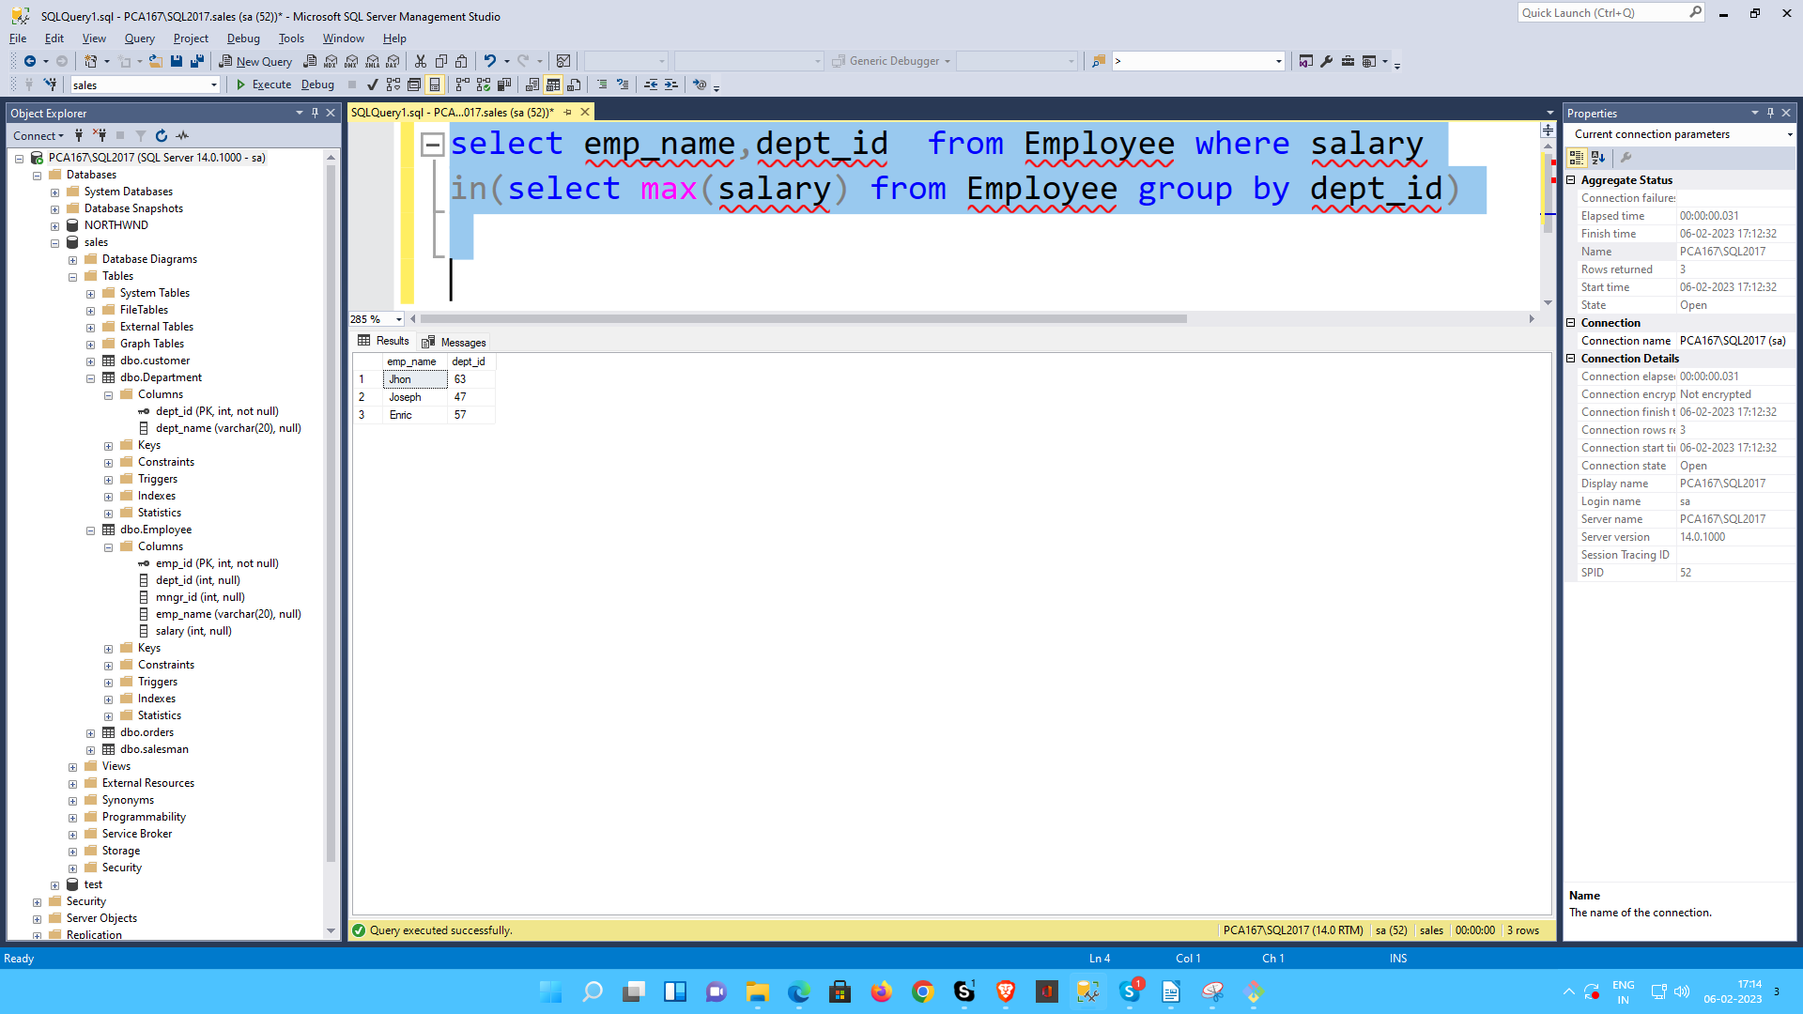

2. write a SQL query to find Departments that have less tha 3 people in it.

select d.dept_name from Department d

where d.dept_id

in(select e.dept_id from Employee e group by e.dept_id

having count(*) < 3)

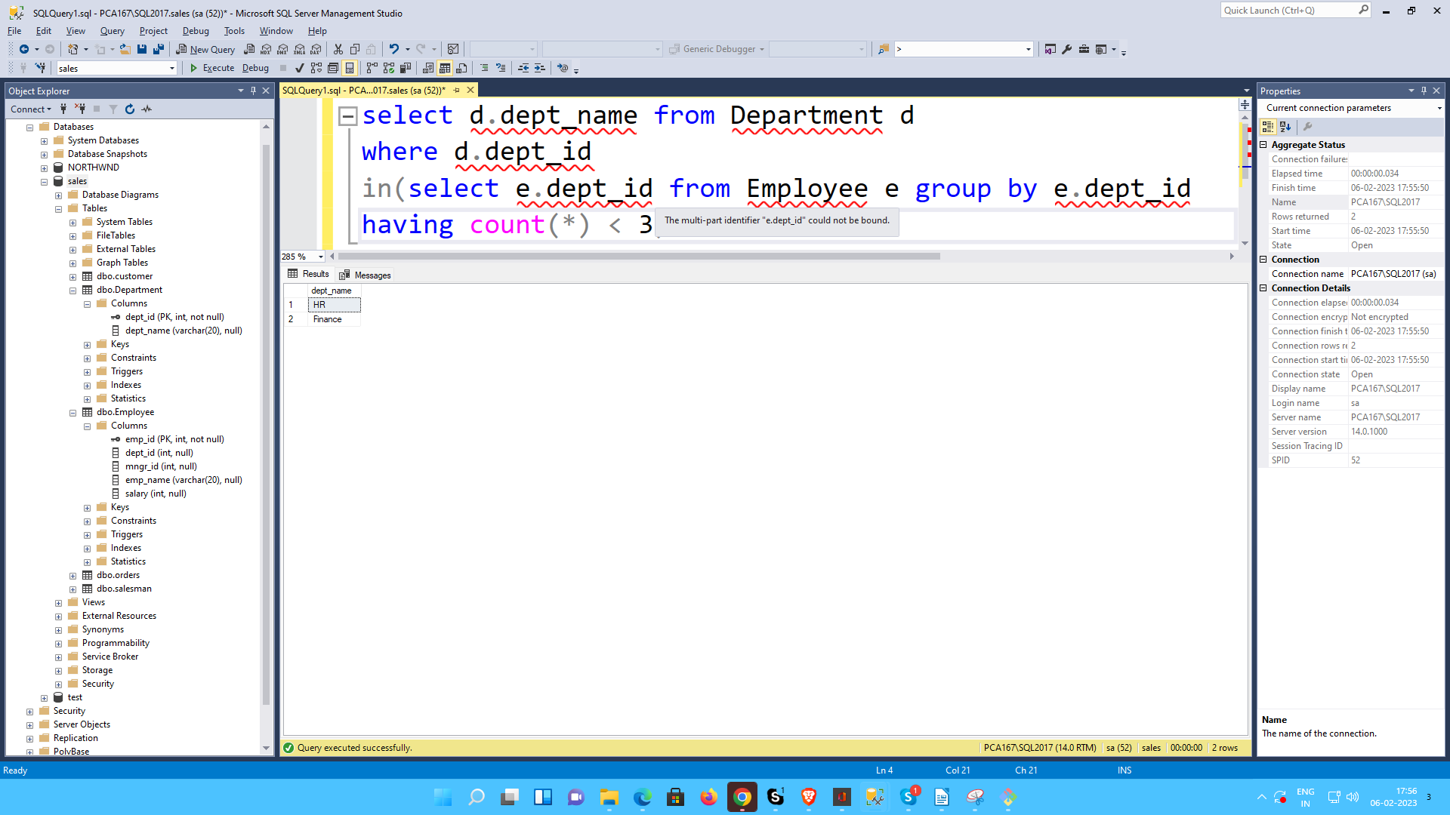

3. write a SQL query to find All Department along with the number of people there

select d.dept_name,count(dept_name) "No. of Employees"

from Department d join Employee e on

d.dept_id=e.dept_id group by d.dept_id,d.dept_name

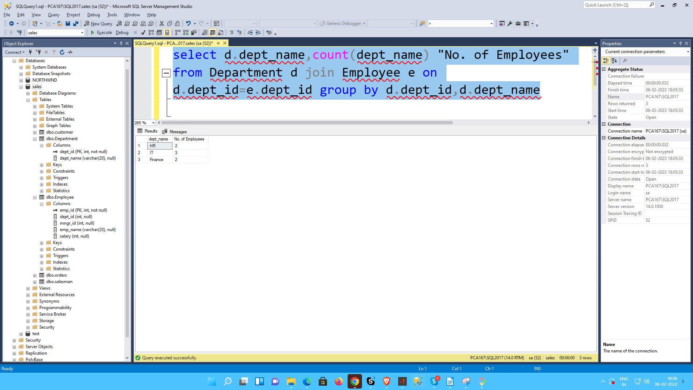

4. write a SQL query to find All Department along with the total salary there

select d.dept_name,sum(salary) "Total Salary"

from Department d join Employee e on

d.dept_id=e.dept_id group by d.dept_id,d.dept_name

